

Technical Report

Title of report

Student Name

Walaa Zaghloula

Word count

Summary: 250 | Main text:500

Table of Contents

1. Summary 3

2. Body 4

2.1. Introduction 4

2.2. Main section of report 4

2.3. Conclusion 4

3. References 5

4. Acknowledgements 6

5. Appendices 7

# 1. Summary

In this assignement, i have to create a website for a cycling tours company which provides cycling tours services to people who love to cycle.

In order to come with the best design, i had to do some researches to understand what cycling tours is and how other companies designed their websites and how they presents their idea.

During my researches, i browsed some companies websites which provide similar services in order to get some points,

the most important point i noticed was how easy its to find the tour you want based on locations you provided, also i noticed that these websites focus more on nature and landscape images which give a indirect feeling about outdoor tour.

So, based on what i have learned so far, i started to convert this knowledge into a nice website design that cover most of the important points.

## 

## Introduction

After finish researching, i started my process by doing some manual sketching and paper drawing which i found very useful as i can easily adjust , edit the design before implementing it as a web code.

## Main section of report

I have designed four pages which i belive is required for such a service or website.

The first page is the home page, where i implemented a simple header containing the company logo and a quick links for my account link, contact details, etc. under the header i added a nav bar which contain the four pages links for easy navigating between pages, with white color text and clear font & size, with different background color on the current visited page.

On the content part, i added a full width clear image which refer to the core business idea (Cycling tour) with text that help to understand the image point “Explore the world by cycle”.

The second part of the content is to show the company featured services as multiple columns which adjust accordingly as the screen resolution changes, which meet the responsiveness concept.

Down to the footer, i added a small form for subscribing to the latest featured tours and special offers.

On the footer, i have chosen to make it as simple as possible by adding quick links to the company social media accounts pages, as such services is super active on social media sites these days.

A second most important page is the “Tours” page, which has the information about the current trending tours , so i implemented similar header & nav as the home page, with different image in the content, and adding the current active tours with information about each one such as duration, price, and a google map iframe to check the route on google maps.

The third page is the about us where i specified the company history and their business informations.

The fourth page is the contact page, where i specified two columns , one to have a form to submit a request to the customer support and one has the contact details for the company such as location, phone number, email etc..

## Conclusion

In this assignment , i improved my skills with developing responsive webistes by using & practicing the “media query” in my CSS to provide different design on different screen resolutions.

Also i started to get more familiar with different types of designs based on each business idea and how the design plays a big role in getting better reputation over the competitors.

# 3. References

*<https://internetingishard.com/html-and-css/responsive-design/>

*<https://www.w3schools.com/css/css_rwd_intro.asp>

*<https://www.w3schools.com/css/css3_mediaqueries.asp>

*<https://www.youtube.com/watch?v=2KL-z9A56SQ>

# 4. Acknowledgements

I have learned designing the website layout is always the first step

In this stage, i don’t have to think of a responsive design yet. Just focus on building the website layout.

Once i finish the design and development, i should launch my website and test it. I need to test my website on as many different devices as i can.

Home page

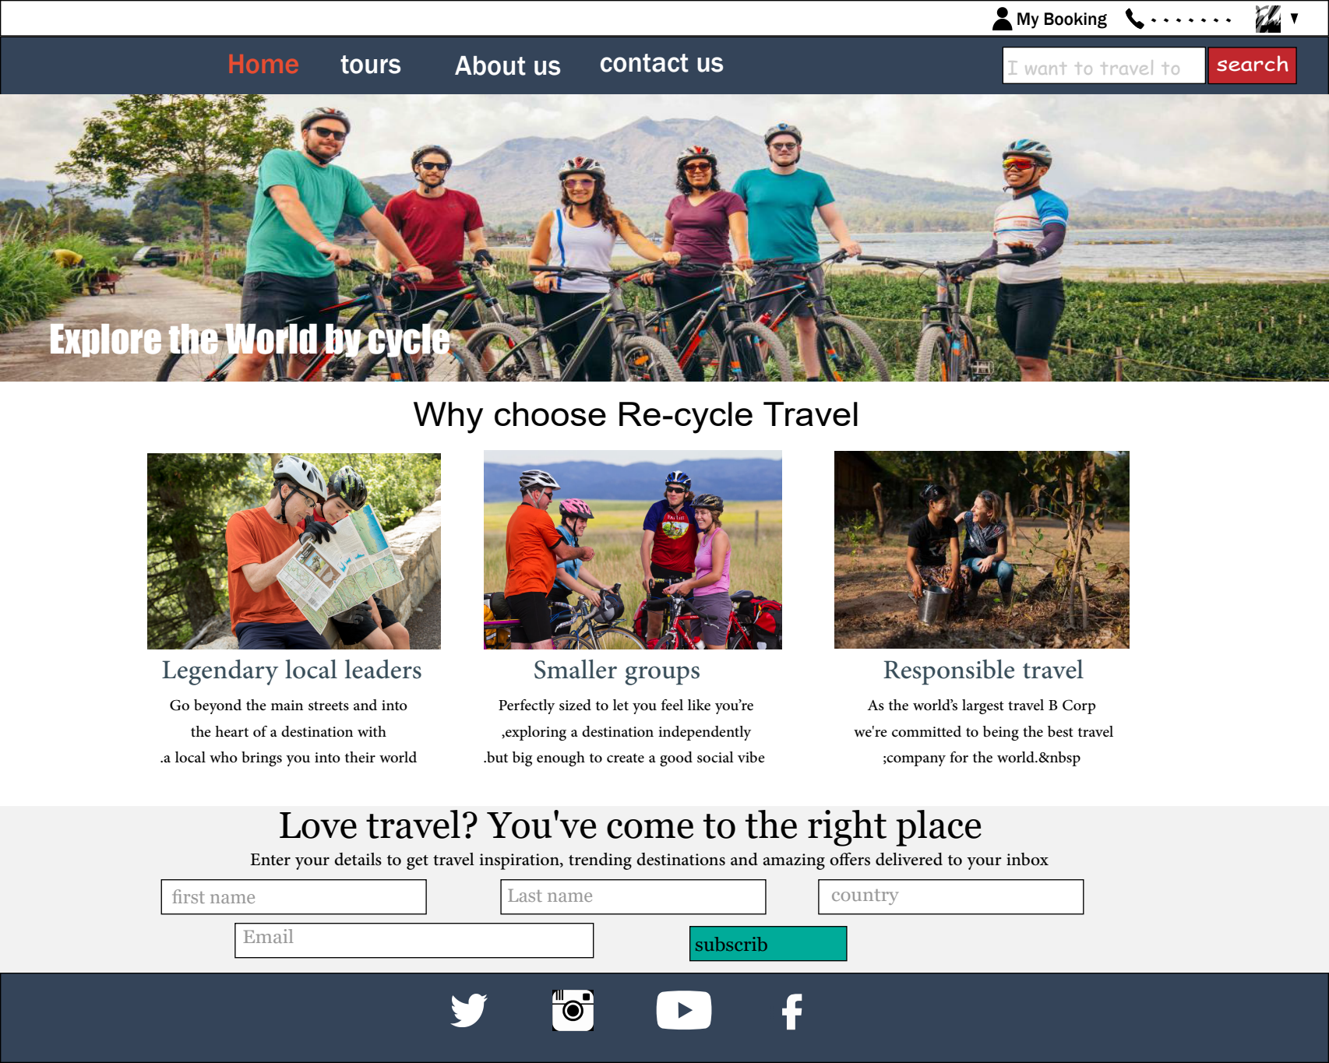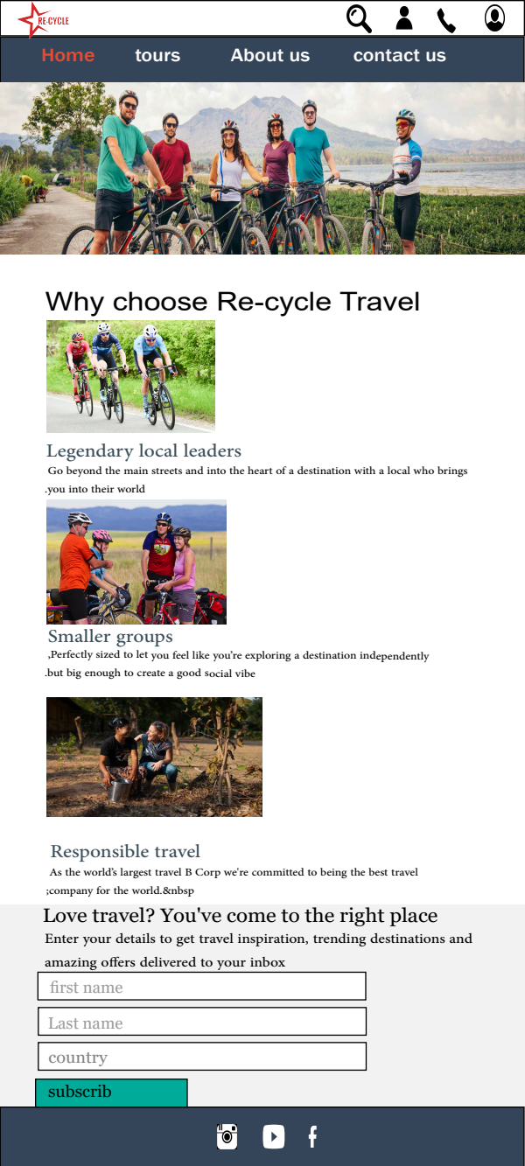

tours peag

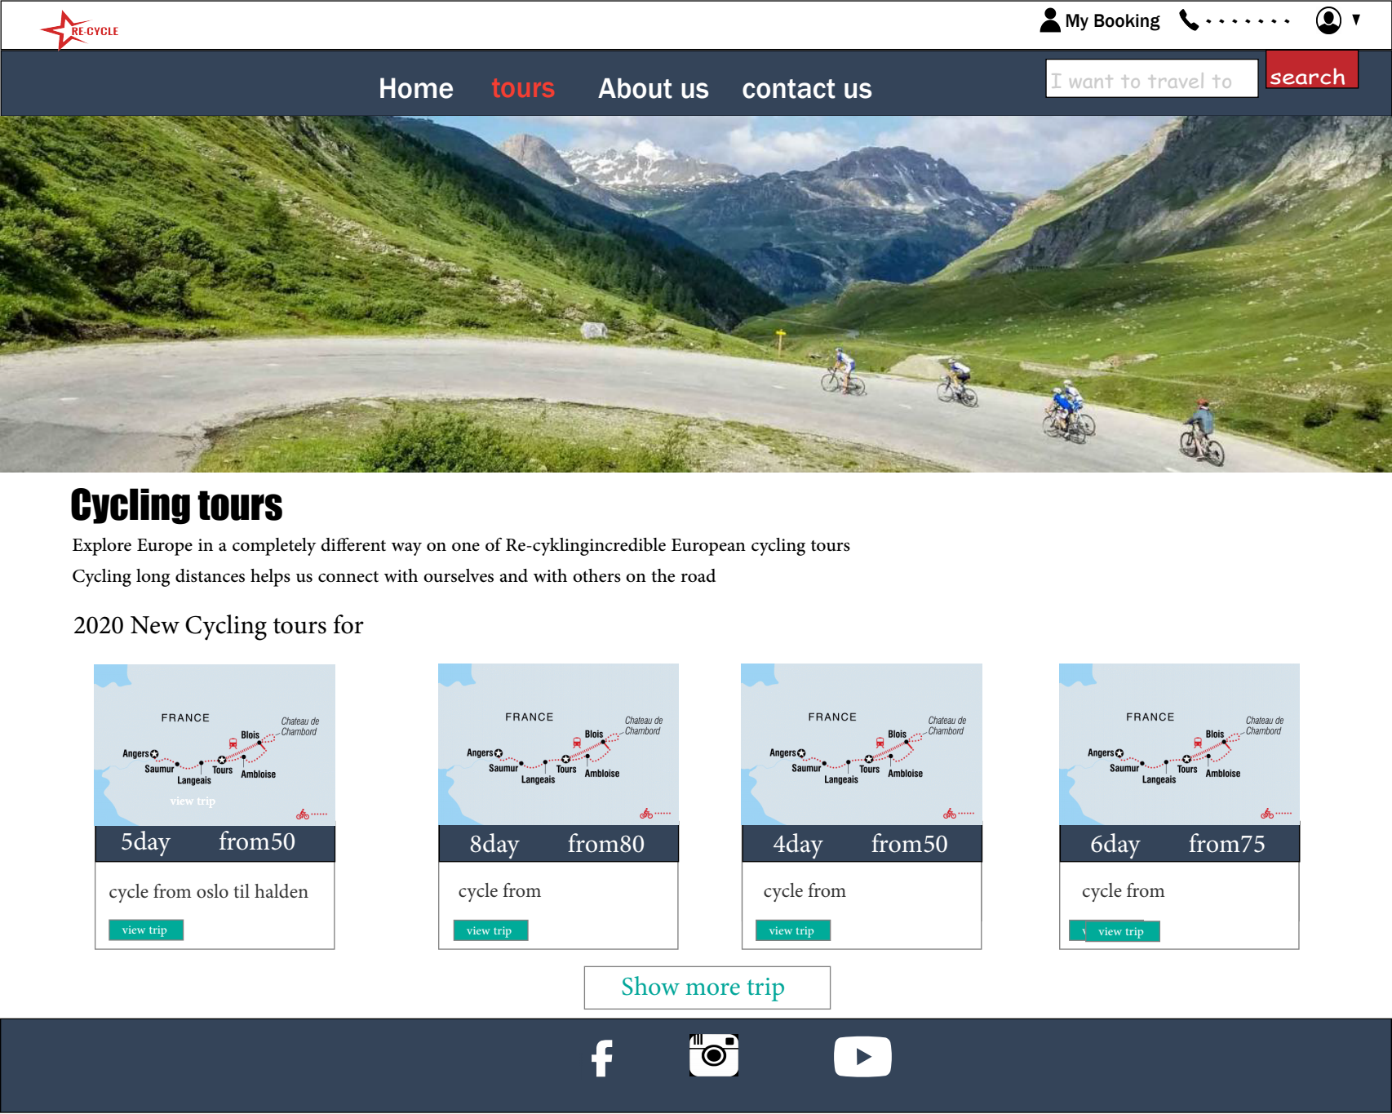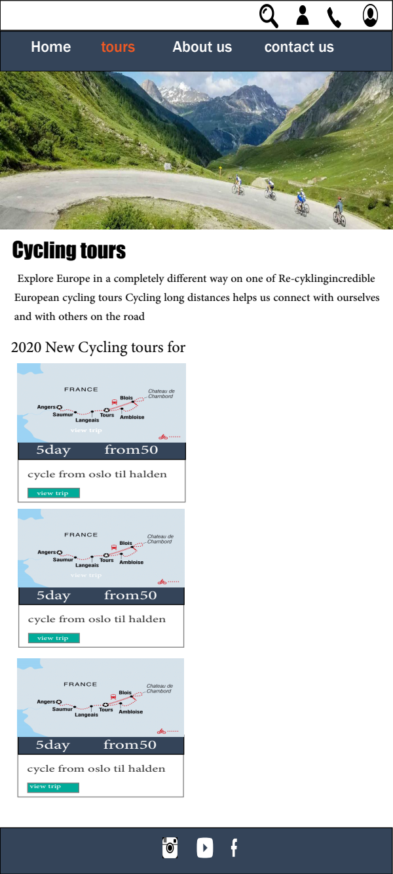

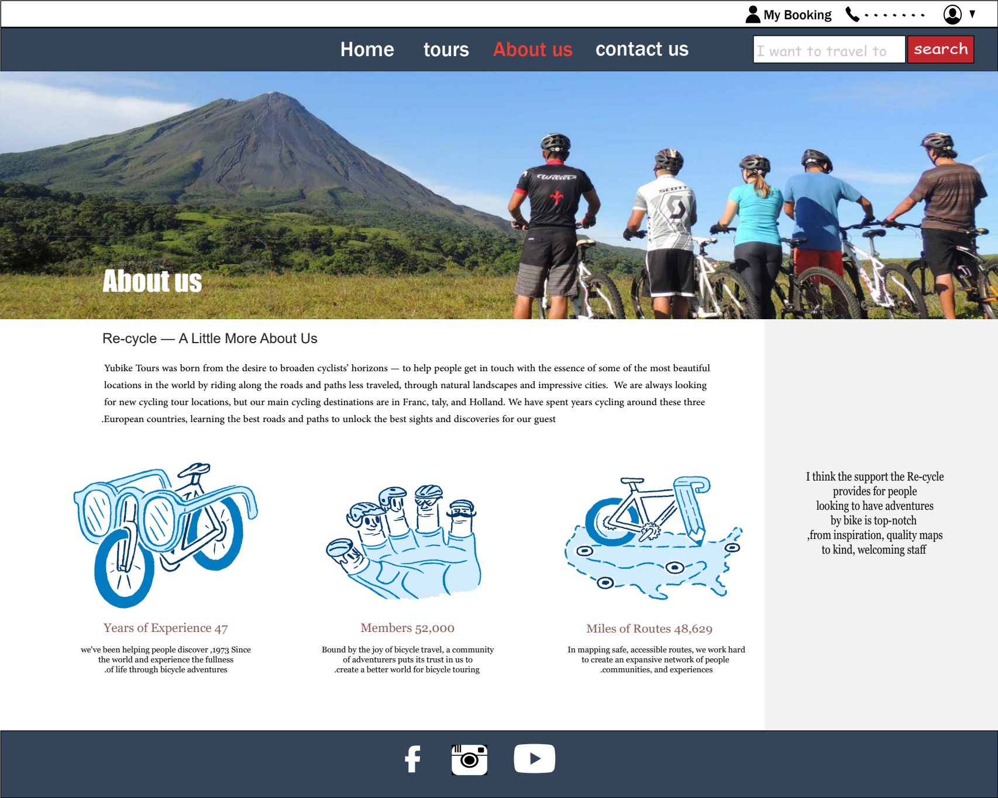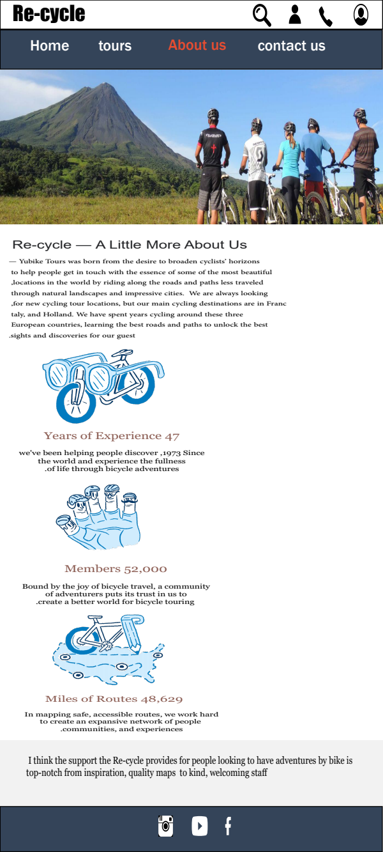 About us

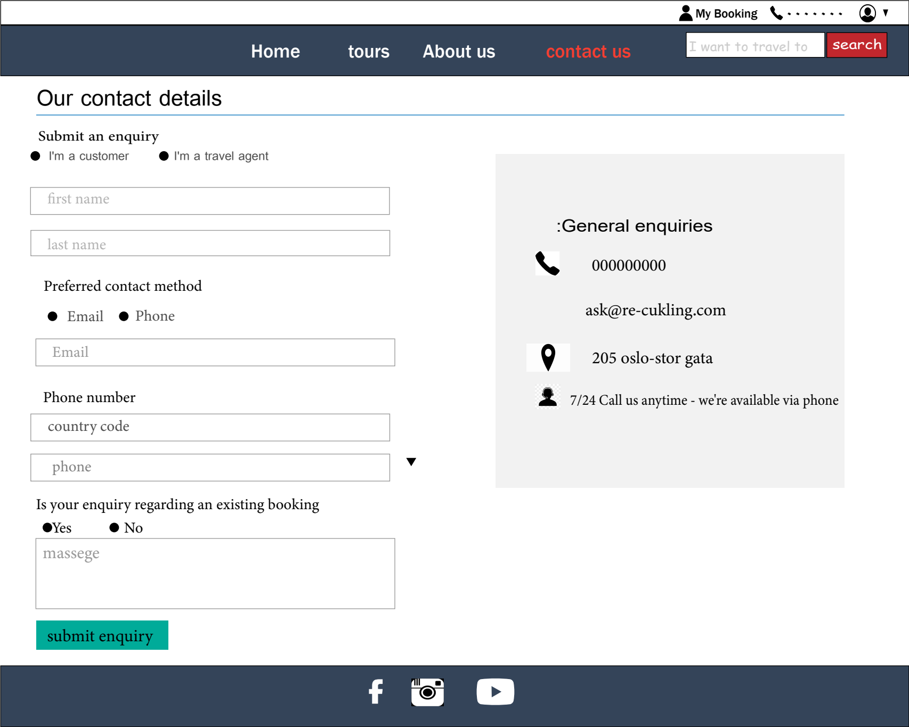 contact us

